NFB High-Efficiency Condensing Fire Tube Boiler
Engineering Specification
Model 175,000 Btu/hr. and 199,900 Btu/hr.

- General Requirements
  - Project scope
    - Supply and install ____ (qty) high-efficiency condensing boiler(s), sealed combustion, modulating, and power vented that use either outside or inside air for combustion.

  - Acceptable manufacturers
    - The Boiler shall be a Navien NFB ____ as basis of design with an input rating of ____ Btu/hr. and an output of ____ Btu/hr. It shall be capable of operating on either natural gas (NG) or propane (LP) with the following performance:

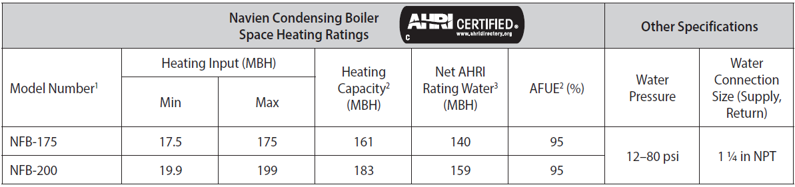

    - The boiler shall have a minimum 10 to 1 turndown ratio with the full modulation range between the maximum and the minimum output levels.
    - The boiler shall be capable of operating on natural gas (NG) or propane (LP) gas. The normal operation of the boiler with natural gas pressure shall be between 3.5 inches of W.C. and 10.5 inches of W.C. The normal operation of the boiler with propane gas pressure shall be between 8.0 inches of W.C. and 13.5 inches of W.C.

  - Installation
    - The boiler shall be installed according to Navien’s installation and operation manual.

- Required Certifications
  - The boiler shall be certified to the ANSI Z21.13 / CSA 4.9 - 2017 Gas-fired Boiler Standard and ANSI Z223.1/NFPA 54 CSA B149.1
  - The boiler shall be certified and listed by C.S.A. Group under the latest edition of the ANSI Z21.13 for the U.S. and Canada.
  - The boiler shall bear the ASME “H” stamp for 80 psi maximum working pressure and shall be National Board listed.
  - The boiler’s AFUE shall be verified by the Hydronics Institute of AHRI and listed in the AHRI Certification Directory.
  - The boiler shall be certified for low NOx sub 14 ng/J or 20 PPM at 3% O₂ and shall be listed in the South Coast Air Quality Management District directory.
  - The boiler shall be fully factory packaged in acceptance for ASME CSD-1.
  - The boiler controls shall be certified by CSA, UL, or equivalent.
  - All electrical components shall be certified by CSA, UL, or equivalent.

- Product Design

  - Enclosure
    - The enclosure shall be constructed of cold-rolled carbon steel, primed and painted on both sides.
    - The maximum boiler dimensions shall be: 17.3 in. (width) x 17.3 in. (depth) x 27.6 in. (height).
    - The maximum boiler weight shall be 123 lb. (56 kg).

  - Heat exchanger and combustion components
    - The heat exchanger shall be constructed of high quality stainless steel, fire tube design with top and bottom ends pressed and not welded. The condensate collection base shall be constructed of non-metallic material.
    - The heat exchanger shall be able to operate with a 50% mixture of propylene glycol without significant loss of performance.
    - The burner shall be a premix design made with stainless steel and a woven metal fiber covering mesh to provide a wide range of modulating firing rates. The burner and flame observation port shall be provided for visual inspection during boiler operation. The burner flame shall be ignited by direct spark ignition and monitored by the flame sensor.
    - The negative pressure regulating gas valve shall use the fan venturi effect to pull the gas through the valve in the correct ratio to inlet air.
    - The boiler shall be equipped with a variable speed blower capable of modulating the boiler firing rate from 100% down to 10% and providing smooth operation throughout the entire operating range.

  - Venting and combustion air configurations
    - The boiler shall be capable of using either outside air (direct vent system) or inside air (non-direct vent system using single pipe) for combustion. Inlet and outlet of the vent system shall be connected to either through-the-roof or sidewall terminations and shall be tested for unbalanced (different pressure zones) locations.
    - Air intake acceptable venting materials include ABS, PVC, CPVC, PP, SS, galvanized steel, and corrugated aluminum. Total equivalent vent length shall be up to 60 ft. using 2” pipe and up to 150 ft. using 3” pipe.
    - Exhaust (flue gases) shall be vented using PVC Schedule 40 (solid core), CPVC Schedule 40 or 80 (solid core), SS and approved polypropylene as referenced in the boiler installation manual. Total equivalent vent length shall be up to 60 ft. using 2” pipe and up to 150 ft. using 3” pipe.
    - Common venting flue gases shall use Category IV approved materials. Maximum of eight (8) boilers can be connected to a common vent with the use of the Common Vent Backflow Damper Collar Kit. All boilers shall be of equal size and type.

  - Electrical
    - The main power supply shall be 110-120 VAC, 60 Hz, three phase and shall not exceed 15 Amps. The boiler shall be supplied with a factory-installed 3-pronged (grounded) plug.
    - The boiler terminal strip shall be equipped with 120 VAC power for 3 zone pumps, 24 VAC power for 3 zone valves, 3 thermostats, LWCO, Navien Smartzone zone pump controller, supply/return temperature sensors, outdoor air temperature sensor, alarm contacts, DHW tank, air handler interrupt, and cascading control for up to 16 boilers.

  - Controls shall be certified and furnished with the following features:
    - Backlit Control panel with LCD type display, clear language text, Select Mode buttons and Command Dial to select and view information
    - Operating temperature limit with 194 deg F maximum boiler water temperature set point
    - High temperature limit control preset at 200 deg F and equipped with manual reset
    - Low water cut off (LWCO) with manual reset
    - ASME certified pressure relief valve set to 30 PSIG provided as standard with an option to furnish 50 PSIG and 80 PSIG relief valves
    - Flue gas, supply and return water temperature sensors
    - High and low gas pressure switches with manual reset
    - Circulator Exercising control logic
    - Built-in freeze protection
    - Warm Weather Shutdown
    - 4 pump contacts (boiler, zone1/DHW, zone2 and zone 3/system)
    - Fully customizable outdoor temperature reset curve provided along with an outdoor temperature sensor for field installation
    - Multiple boiler system functionality including lead/lag capability up to 16 boilers cascading and main boiler rotation
    - Alarm contacts indicating manual reset lockouts on flame failure, high temperature limits, high pressure limits, low water cut off limits and air pressure limits
    - Flame sensor rod
    - History of alarms, operating conditions, failures and user notifications
    - Control capability to communicate with NaviLink to control temperatures remotely, access usage data and receive diagnostic notifications

- Warranty
  - The heat exchanger shall have fifteen (15) year limited warranty for residential applications and ten (10) year limited warranty for commercial applications.
  - All other parts of the boiler shall have five (5) year warranty for residential applications and three (3) year warranty for commercial applications covering defects in materials and workmanship.
  - The labor warranty shall be one (1) year.
  - The warranty period shall be based on the date of manufacture or the date of installation (whichever period is longer).
  - The warranty period for an installation in a new construction shall commence from the date the end-user obtains title to the property from the developer or builder and not the date of installation.

- Manuals
  - Complete set of documents including product brochure, installation manual, user manual, wiring diagrams, piping diagrams, controls sequences, engineering specification, submittals and warranties shall be submitted for approval at least seven days before the bid date.

