NCB-E High-Efficiency Condensing Combination Boiler
Engineering Specification
Model 120,000 Btu/hr. - 199,900 Btu/hr.

- General Requirements
  - Project scope
    - Supply and install ____ (qty) high-efficiency condensing combination boiler(s), sealed combustion, modulating, and power vented that use either outside or inside air for combustion.

  - Acceptable manufacturers
    - The Boiler shall be a Navien NCB ____ as basis of design with an input rating of ____ Btu/hr. and an output of ____ Btu/hr. It shall be capable of operating on either natural gas (NG) or propane (LP) with the following performance:

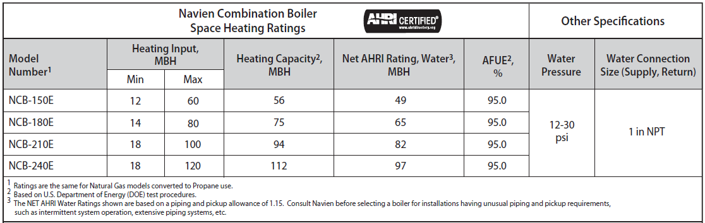

    - The boiler shall have a minimum 5 to 1 turndown ratio with the full modulation range between the maximum and the minimum output levels.
    - The boiler shall be capable of operating on natural gas (NG) or propane (LP) gas. The normal operation of the boiler with natural gas pressure shall be between 3.5 inches of W.C. and 10.5 inches of W.C. The normal operation of the boiler with propane gas pressure shall be between 8.0 inches of W.C. and 13.5 inches of W.C.

  - Installation
    - The boiler shall be installed according to Navien’s installation and operation manual.

- Required Certifications
  - The boiler shall be certified to the ANSI Z21.13 / CSA 4.9-2017 Gas-fired Boiler Standard and ANSI Z223.1/NFPA 54 CSA B149.1
  - The boiler shall be certified and listed by C.S.A. International under the latest edition of the ANSI Z21.13 for the U.S. and Canada.
  - The boiler shall bear the ASME “H” stamp for 80 psi maximum working pressure and shall be National Board listed.
  - The boiler’s AFUE shall be verified by the Hydronics Institute of AHRI and listed in the AHRI Certification Directory.
  - The boiler shall be certified for low NOx sub 14 ng/J or 20 PPM at 3% O₂ and shall be listed in the South Coast Air Quality Management District directory.
  - The boiler shall be fully factory packaged in acceptance for ASME CSD-1.
  - The boiler controls shall be certified by CSA, UL, or equivalent.
  - The boiler shall have CRN registrations
  - All electrical components shall be certified by CSA, UL, or equivalent.

- Product Design

  - Enclosure
    - The enclosure shall be constructed of cold-rolled carbon steel, primed and painted on both sides.
    - The maximum boiler dimensions shall be: 17.0 in. (width) x 12.0 in. (depth) x 28.0 in. (height).
    - The maximum boiler weight shall be 84 lb. (38 kg).

  - Heat exchanger and combustion components
    - The primary and secondary heat exchangers shall be constructed of stainless steel material and engineered to attain the highest level of heat transfer in a compact design. To accomplish this, the heating water shall flow through a series of tubes (secondary heat exchanger) and finned tubes (primary heat exchanger), designed to maximize the heat transfer area.
    - The DHW flat plate heat exchanger installed inside the combination boiler shall be constructed of stainless steel material, tested and certified in accordance with IAPMO standard PS 92-2013.
    - The heat exchanger shall be able to operate with a 35% mixture of propylene glycol without significant loss of performance.
    - The burner shall be a premix design made with stainless steel and a woven metal fiber covering mesh to provide a wide range of modulating firing rates. The burner and flame observation port shall be provided for visual inspection during boiler operation. The burner flame shall be ignited by direct spark ignition and monitored by the flame sensor.
    - The negative pressure regulating gas valve shall use the fan venturi effect to pull the gas through the valve in the correct ratio to inlet air.
    - The boiler shall be equipped with a variable speed blower capable of modulating the boiler firing rate from 100% down to 20% and providing smooth operation throughout the entire operating range.

  - Venting and combustion air configurations
    - The boiler shall be capable of using either outside air (direct vent system) or inside air (non-direct vent system using single pipe) for combustion. Inlet and outlet of the vent system shall be connected to either through-the-roof or sidewall terminations and shall be tested for unbalanced (different pressure zones) locations.
    - Air intake acceptable venting materials include PVC, CPVC, PP, and SS. Total equivalent vent length shall be up to 60 ft. using 2” pipe and up to 150 ft. using 3” pipe.
    - Exhaust (flue gases) shall be vented using PVC Schedule 40 (solid core), CPVC Schedule 40 or 80 (solid core), SS and approved polypropylene as referenced in the boiler installation manual. Total equivalent vent length shall be up to 60 ft. using 2” pipe and up to 150 ft. using 3” pipe.

  - Electrical
    - The main power supply shall be 110-120 VAC, 60 Hz, three phase and shall not exceed 15 Amps. The boiler shall be supplied with a factory-installed 3-pronged (grounded) plug.
    - The boiler low voltage terminal strip shall have contacts for thermostats or zone controller, outdoor reset, 24 VAC device relay, air handler interrupt, and LWCO

  - Controls shall be certified and furnished with the following features:
    - Backlit Control panel with LCD type display and touch pad allowing to access operating status, error notification, diagnostics, test mode, burner operation mode, set point adjustment, and history of up to 10 error codes
    - Operating temperature limit with 194 deg F maximum boiler water temperature set point and temperature options:
      - Space heating temperature range from 77 deg F up to 194 deg F
      - DHW temperature range from 86 deg F up to 140 deg F
    - High temperature limit control preset at 200 deg F and equipped with manual reset
    - Low water cut off (LWCO) with manual reset
    - ASME certified pressure relief valve set to 30 PSIG provided as standard
    - Flue gas, supply and return water temperature sensors
    - High and low gas pressure switches with manual reset
    - Domestic hot water priority
    - Capability to cascade with up to 15 tankless water heaters for increased DHW output
    - Built-in circulator pump
    - Built-in freeze protection
    - Fully customizable outdoor temperature reset curve provided along with an outdoor temperature sensor for field installation
    - Flame rod sensor
    - Control capability to communicate with NaviLink WIFI to control temperatures remotely, access usage data and receive diagnostic notifications

- Warranty
  - The heat exchanger shall have ten (10) year limited warranty for residential applications.
  - All other parts of the boiler shall have five (5) year warranty for residential applications covering defects in materials and workmanship.
  - The labor warranty shall be one (1) year.
  - The warranty period shall be based on the date of manufacture or the date of installation (whichever period is longer).

- Manuals
  - Complete set of documents including product brochure, installation manual, user manual, wiring diagrams, piping diagrams, controls sequences, engineering specification, submittals and warranties shall be submitted for approval at least seven days before the bid date.

