NFB700-C High-Efficiency Condensing Boiler Engineering Specification
MODELS
500-C (499 MBH) 600-C (599 MBH) 800-C (799 MBH) 1000 (999 MBH)

- General Requirements
Project scope
  - Supply and install ____ (qty) high-efficiency condensing boiler(s), sealed combustion, modulating, and power vented that use either outside or inside air for combustion.
  - Acceptable manufacturers
    - The Boiler shall be a Navien NFB700 ____ as basis of design with an input rating of ____ MBH and an output of ____ MBH. It shall be capable of operating on either natural gas (NG) or propane (LP) with the following performance:

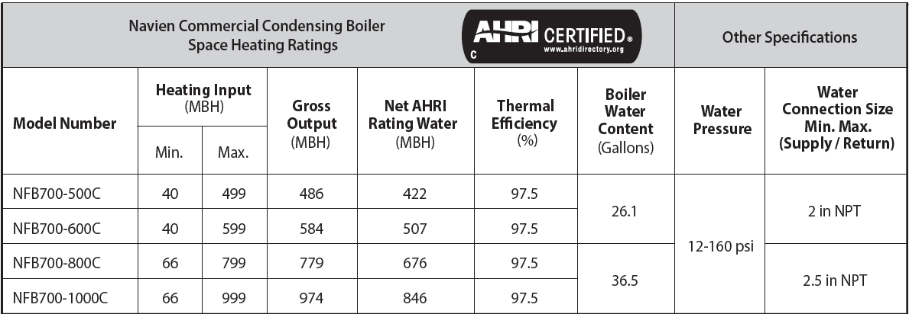

    - The boiler shall have a minimum 12 to 1 turndown ratio with the full modulation range between the maximum and the minimum output levels.
    - The boiler shall be capable of operating on natural gas (NG) or propane (LP) gas. The normal operation of the boiler with natural gas pressure shall be between 3.5 inches of W.C. and 10.5 inches of W.C. The normal operation of the boiler with propane gas pressure shall be between 8.0 inches of W.C. and 13.5 inches of W.C.
  - Installation
    - The boiler shall be installed according to Navien’s installation and operation manual.

- Required Certifications
  - The boiler shall be certified to the ANSI Z21.13 / CSA 4.9 - 2017 Gas-fired Boiler Standard and ANSI Z223.1/NFPA 54 CSA B149.1
  - The boiler shall be certified and listed by C.S.A. Group under the latest edition of the ANSI Z21.13 for the U.S. and CSA 4.9 in Canada.
  - The boiler shall bear the ASME “H” stamp for 160 psi maximum working pressure and shall be National Board listed.
  - The boiler’s Thermal Efficiency shall be verified by the Hydronics Institute of AHRI and listed in the AHRI Certification Directory.
  - The boiler shall be certified for low NOx sub 14 ng/J or 20 PPM at 3% O₂ and shall be listed in the South Coast Air Quality Management District directory.
  - The boiler controls shall be certified by CSA, UL, or equivalent.
  - All electrical components shall be certified by CSA, UL, or equivalent.

- Product Design
  - Enclosure
    - The enclosure shall be constructed of cold-rolled carbon steel, primed and painted on both sides.
    - The maximum boiler dimensions shall be: 28.3 in. (width) x 33.0 in. (depth) x 73.3 in. (height).
    - The maximum boiler weights (dry weight) shall be:
551 lb. (NFB700-500C & NFB700-600C)
728 lb. (NFB700-800C & NFB700-1000C)
  - Heat exchanger and combustion components
    - The heat exchanger shall be a fire tube design constructed of high quality stainless steel material.
    - The combustion chamber shell be one-piece form pressed and not welded.
    - The heat exchanger shall be able to operate up to 50% mixture of propylene glycol without significant loss of performance.
    - The burner shall be a premix design made with stainless steel and a woven metal fiber covering mesh to provide a wide range of modulating firing rates. The burner flame shall be ignited by direct spark ignition and monitored by the flame sensor.
    - The negative pressure regulating gas valve shall use the fan venturi effect to pull the gas through the valve in the correct ratio to inlet air.
    - The boiler shall be equipped with a variable speed blower capable of modulating the boiler firing rate from 100% down to 8.3% and providing smooth operation throughout the entire operating range.
  - Venting and combustion air configurations
    - The boiler shall be capable of using either outside air (direct vent system) or inside air (non-direct vent system using single pipe) for combustion. Inlet and outlet of the vent system shall be connected to either through-the-roof or sidewall terminations and shall be tested for unbalanced (different pressure zones) locations.
    - Air intake acceptable venting materials include ABS, PVC, CPVC, PP, SS, galvanized steel, and corrugated aluminum. Total equivalent length shall be up to 150 ft (4” pipe for 500C & 600C, 6” pipe for 800C & 1000C) .
    - Exhaust (flue gases) shall be vented using PVC Schedule 40 (solid core), CPVC Schedule 40 or 80 (solid core), SS and approved polypropylene as referenced in the boiler installation manual. Total equivalent vent length shall be up to 150 ft (4” pipe for 500C & 600C, 6” pipe for 800C & 1000C).
    - Common venting flue gases shall use Category IV approved materials. Maximum of four (4) boilers can be connected to a common vent with the use of the Common Vent Backflow Damper Collar Kit. All boilers shall be of equal size and type.
  - Water connections
    - The boiler shall be used in a closed loop pressurized system and require a properly sized thermal expansion tank to meet local codes.
    - Water connection sizes, both supply and return, shall be standard 2 in. for the NFB700-500C & 600C, 2.5” for the NFB700-800C & 1000C.
  - Electrical
    - The main power supply shall be 110-120 VAC, 60 Hz, single phase and shall not exceed 20 Amps.
    - The boiler printed circuit board shall be equipped with dry contacts rated for 5A/120VAC to connect 4 zone pumps, boiler pump, LWCO, 4 thermostats, Navien Smartzone zone pump controller, supply/return temperature sensors, outdoor air temperature sensor, alarm contacts, DHW tank, air handler interrupt, and cascade control for up to 8 boilers.
  - Controls shall be certified and furnished with the following features:
    - Control system shall include a built-in 10-inch color touch screen allowing to turn the boiler on and off, monitor boiler operation, change operating mode (space heating and DHW), adjust operating parameters, set up cascade operation and view history of errors and notifications.
    - Low water cut off (LWCO) with manual reset
    - ASME certified pressure relief valve set to 50 PSIG provided as standard with an option to furnish 75 PSIG and 150 PSIG relief valves
    - Flue gas, supply and return water temperature sensors
    - Warm Weather Shutdown
    - 5 pump contacts (boiler, zone 1 / DHW, zone 2, zone3, and zone 4 / system)
    - Fully customizable outdoor temperature reset curve provided along with an outdoor temperature sensor for field installation
    - Multiple boiler system functionality including lead/lag capability up to 8 boilers cascading and lead boiler rotation for equal run hours
    - Contacts indicating manual reset lockouts on flame failure, high temperature limits, high water pressure limits, low water cut off limits and air pressure limits
    - Flame sensing rod
    - Low and High gas pressure switches
    - History of alarms, operating conditions, failures and user notifications
    - Control capability to communicate with NaviLink to control temperatures remotely, access usage data and receive diagnostic notifications
    - Control capability to communicate with Building Management Systems using Modbus, BACnet or LonWorks communication protocols

- Warranty
  - The heat exchanger shall have a ten (10) year limited warranty for commercial applications.
  - All other parts of the boiler shall have a three (3) year warranty for commercial applications covering defects in materials and workmanship.
  - The warranty period shall be based on the date of manufacture or the date of installation (whichever period is newer).
  - The warranty period for an installation in a new construction shall commence from the date the end-user takes title to the real property.

- Manuals
  - Complete set of documents including product brochure, installation manual, user manual, wiring diagrams, piping diagrams, controls sequences, engineering specification, submittals and warranties shall be submitted for approval at least seven days before the bid date.

